**Installing HP service manager 7.11**

1. **Install SQL Server 2000.**
2. **Start the Services of SQL Server 2000.**
3. **Create the Data Base.**
4. **Create the Login.**
5. **Make the ODBC Connection.**
6. **Install HPSM server.**
7. **Start HPSM Server Services.**
8. **Install Jave JDK.**
9. **Define Java Environment Variable Class Path.**

**My Computer>Property>Advanced>Environment Variable>New**

**Variable Name: JAVA_HOME**

**Variable Value: C:\Program Files\Java\jdk1.5.0_07**

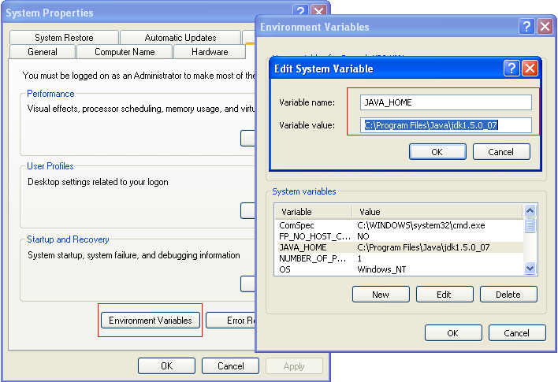

1. **Install HPSM Client.**
2. **Install HPSM Help Server.**
3. **Enable Help Server From the Client.**
4. **Install Tomcat Apache.(Give the installed JDK path during installation. )**

**C:\Program Files\Java\jdk1.5.0_07**

1. **Go to Apache Tomcat Properties> Java Tab, Add the Line in the CLASS PATH.**

**C:\Program Files\Java\jdk1.5.0_07\lib\tools.jar**

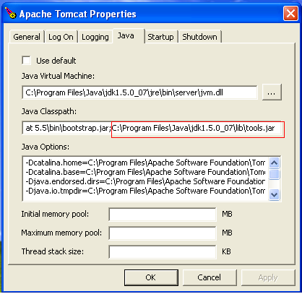

1. **Copy the sm.war file in tomcat Webapps folder.**

**C:\Program Files\Apache Software Foundation\Tomcat 5.5\webapps**

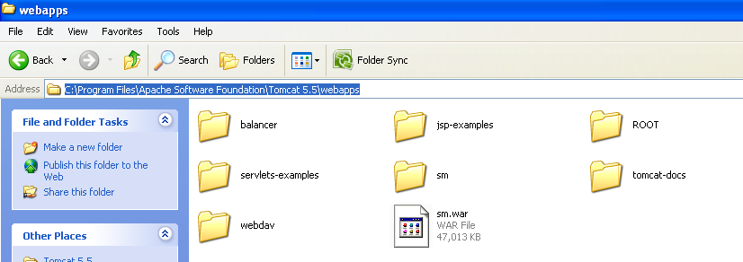

1. **Copy the Java files in common> endorsed folder.**

**C:\Program Files\Apache Software Foundation\Tomcat 5.5\common\endorsed**

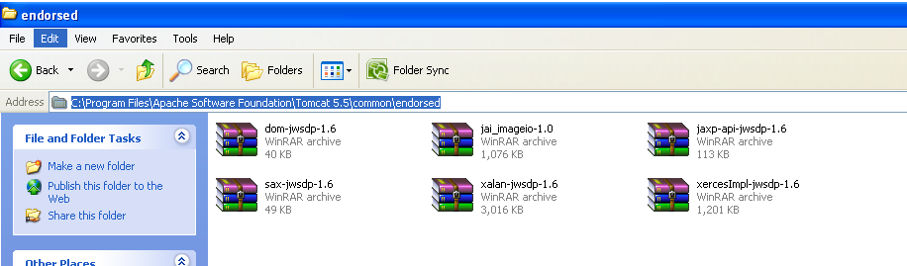

1. **Run the Apache Services.**
2. **Test Apache using the link**

[**http://localhost:8080/sm/ess.do**](http://localhost:8080/sm/ess.do)

[**http://localhost:8080/sm/index.do**](http://localhost:8080/sm/index.do)